1. **Task Description**

Build a "Tic-Tac-Toe" game that allows two players to take turns and determine the winner

1. **Task Output Screenshot**

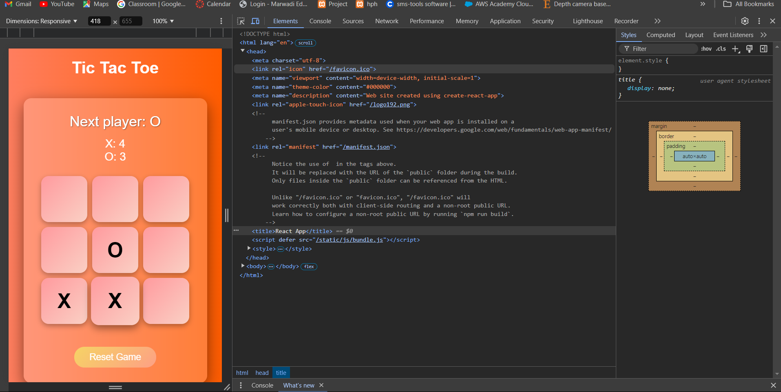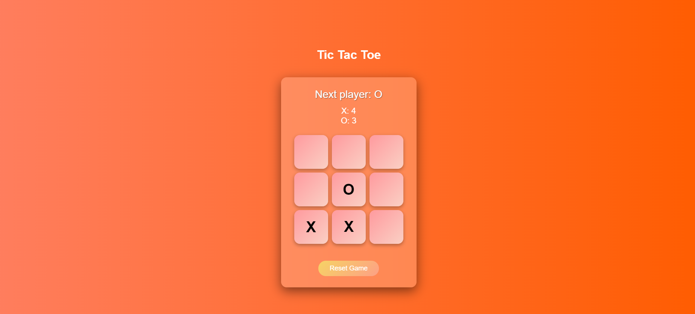

**Widget/Algorithm Used In Task**

* **Button Widget**: Used for the squares of the Tic-Tac-Toe board to allow players to make their moves.
* **Status Display**: Displays the current game status, indicating the next player or the winner.
* **Scoreboard**: Displays the scores for both players (X and O), keeping track of wins.
* **Audio Playback**: Utilizes sound effects to provide audio feedback for player moves and winning conditions.
* **Animation Algorithm**: Implements CSS animations to highlight the winning combination, enhancing the visual feedback during the game.
* **State Management**: React useState hook to manage the game state, including the board configuration and the current player turn.
* **Effect Hook**: Implements useEffect to handle side effects, such as playing sound effects when a player makes a move or when there's a winner.